Test Case: tc001_SPX_Dev5_Crear_Requisicion_Spot_Tipo_Cobro_CC
Step 1 - Enter username and password and click to button Enter : Credentials Entered
Image file-name: QC_Testing-tc001_SPX_Dev5_Crear_Requisicion_Spot_Tipo_Cobro_CC-1788297803117

Step 2 - Select to UEN and Access to Spot Buy Requisitions : UEN Correctly selected and Correct access
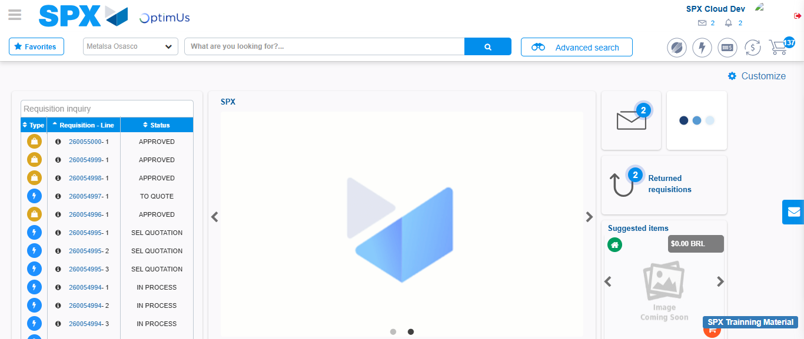Image file-name: QC_Testing-tc001_SPX_Dev5_Crear_Requisicion_Spot_Tipo_Cobro_CC-1788297829732

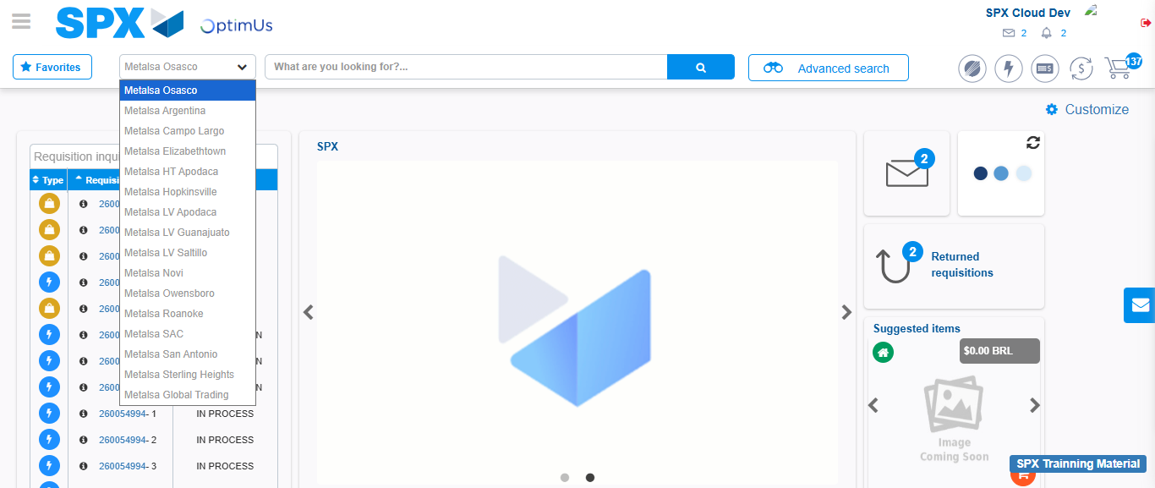Image file-name: QC_Testing-tc001_SPX_Dev5_Crear_Requisicion_Spot_Tipo_Cobro_CC-1788297830338

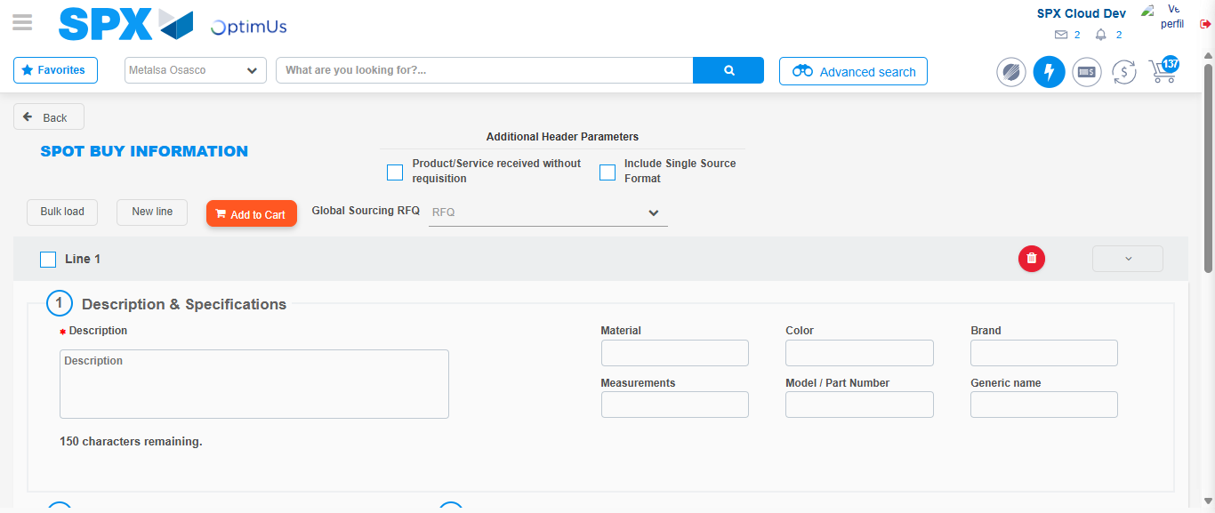Image file-name: QC_Testing-tc001_SPX_Dev5_Crear_Requisicion_Spot_Tipo_Cobro_CC-1788297850841

Step 3 - Data Capture Spot Buy Requisition : Data captured correctly
Image file-name: QC_Testing-tc001_SPX_Dev5_Crear_Requisicion_Spot_Tipo_Cobro_CC-1788297851155

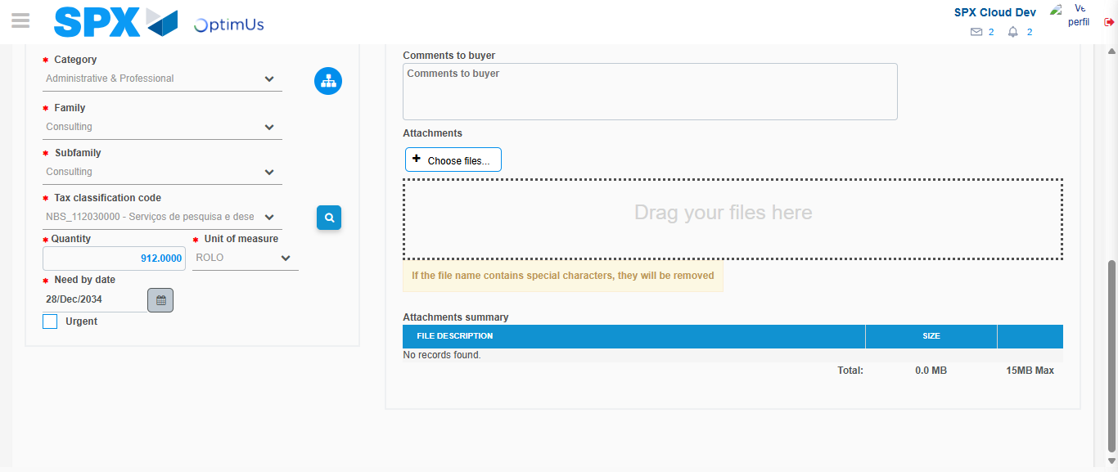Image file-name: QC_Testing-tc001_SPX_Dev5_Crear_Requisicion_Spot_Tipo_Cobro_CC-1788297867236

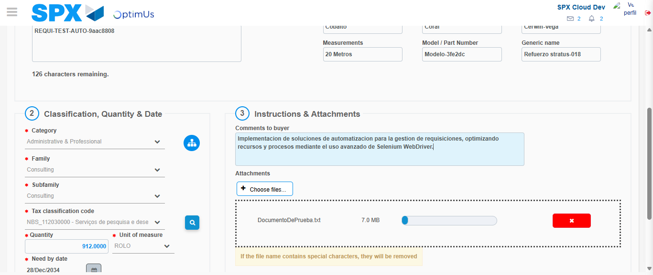Image file-name: QC_Testing-tc001_SPX_Dev5_Crear_Requisicion_Spot_Tipo_Cobro_CC-1788297868118

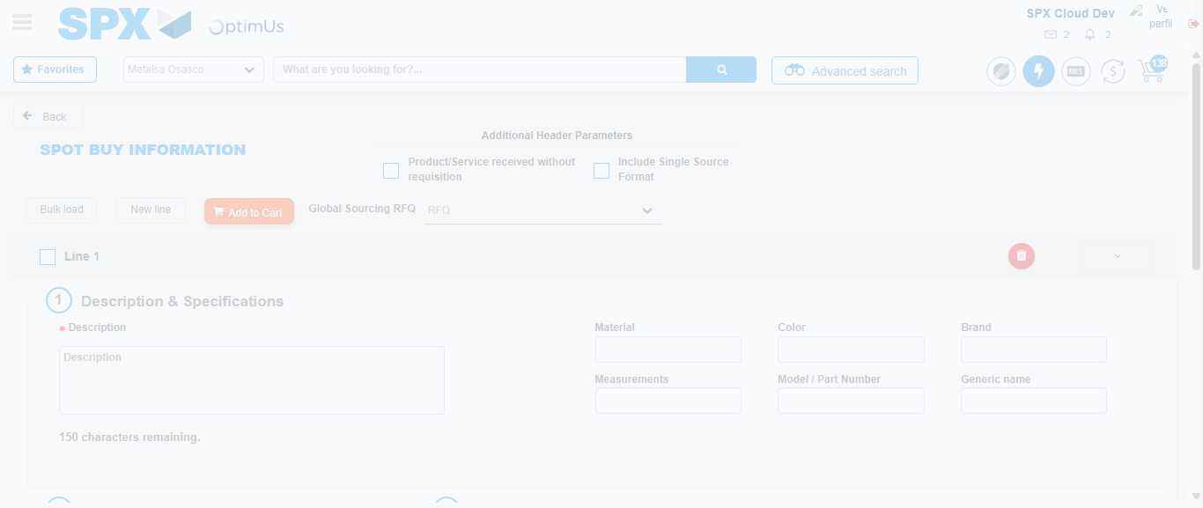Image file-name: QC_Testing-tc001_SPX_Dev5_Crear_Requisicion_Spot_Tipo_Cobro_CC-1788297873283

Step 7 - Return to Main Page SPX : Return to Main Page SPX
Image file-name: QC_Testing-tc001_SPX_Dev5_Crear_Requisicion_Spot_Tipo_Cobro_CC-1788297829732

Image file-name: QC_Testing-tc001_SPX_Dev5_Crear_Requisicion_Spot_Tipo_Cobro_CC-1788297830338

Image file-name: QC_Testing-tc001_SPX_Dev5_Crear_Requisicion_Spot_Tipo_Cobro_CC-1788297850841

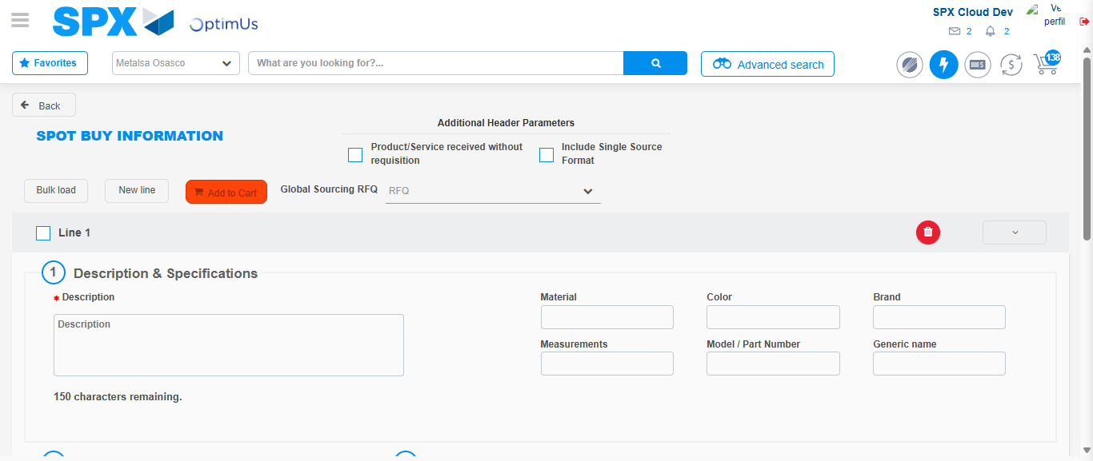Image file-name: QC_Testing-tc001_SPX_Dev5_Crear_Requisicion_Spot_Tipo_Cobro_CC-1788297875559

Image file-name: QC_Testing-tc001_SPX_Dev5_Crear_Requisicion_Spot_Tipo_Cobro_CC-1788297875788

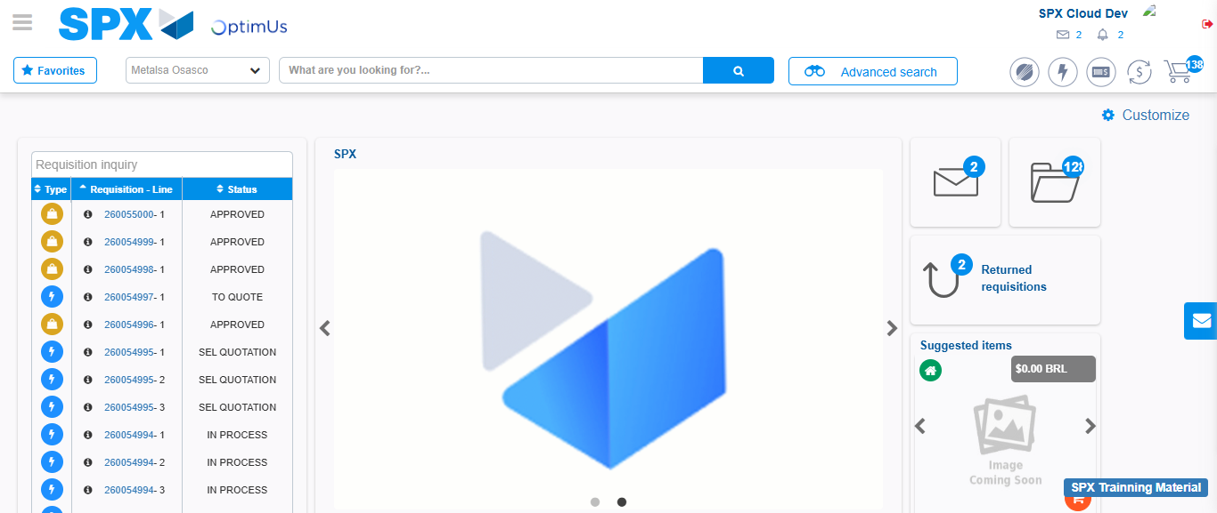Image file-name: QC_Testing-tc001_SPX_Dev5_Crear_Requisicion_Spot_Tipo_Cobro_CC-1788297897032

Step 8 - Log Out : Log Out SPX
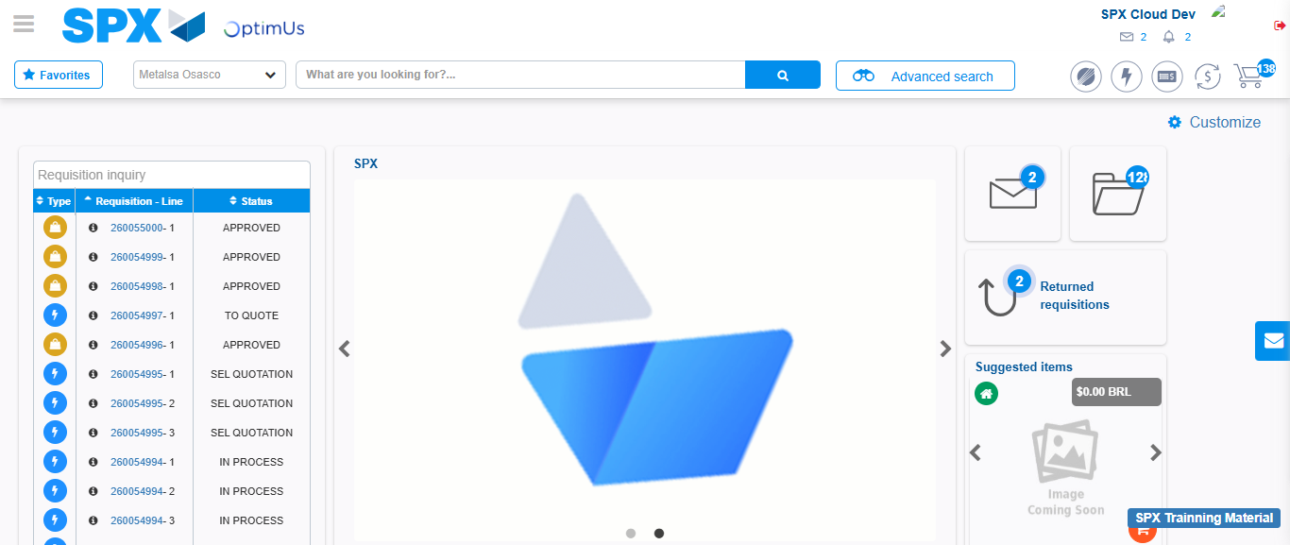Image file-name: QC_Testing-tc001_SPX_Dev5_Crear_Requisicion_Spot_Tipo_Cobro_CC-1788297897423

